EN3160 – Assignment 1 on Intensity Transformations and Neighborhood Filtering

Name – De Silva A.L.U.P.

Index – 200105F

GitHub Link –

Question 01

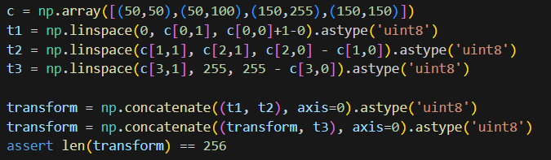

Figure 1 - Generating the Transform

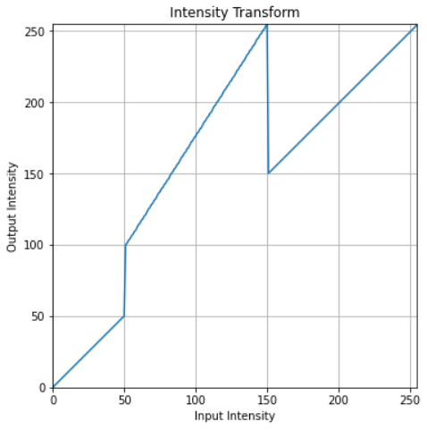

Figure 2 - Intensity Transformation

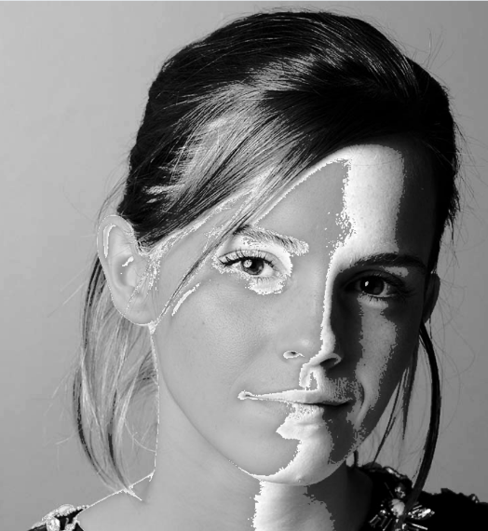

Figure 3(b) - Image after applying transformation

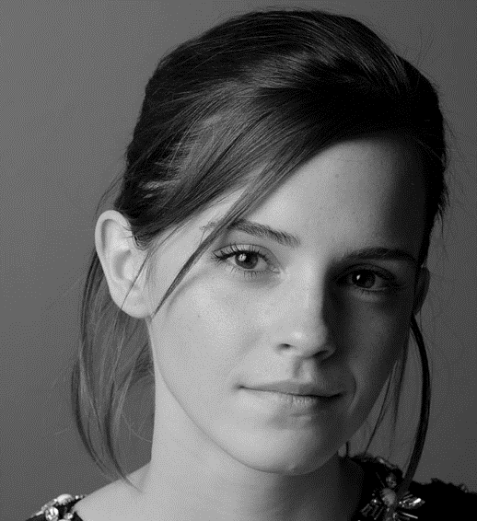

Figure 3(a) - Image before applying transformation

Question 02

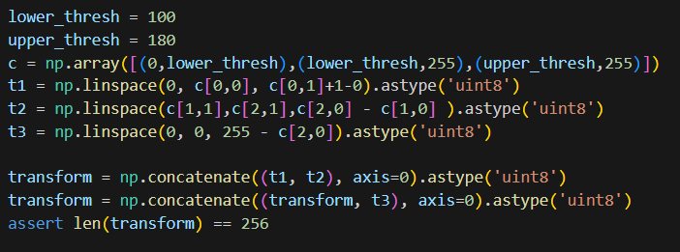

Figure 4(b) - Generating transformation for gray matter

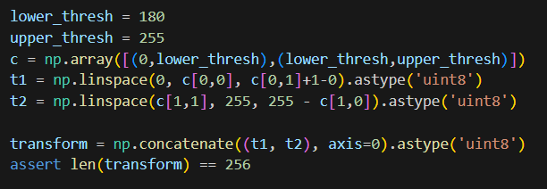

Figure 4(a) - Generating transformation for white matter

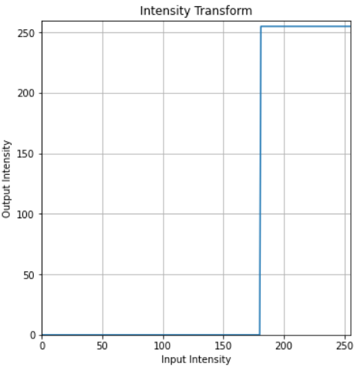

Figure 5(a) - Intensity transformation for white matter

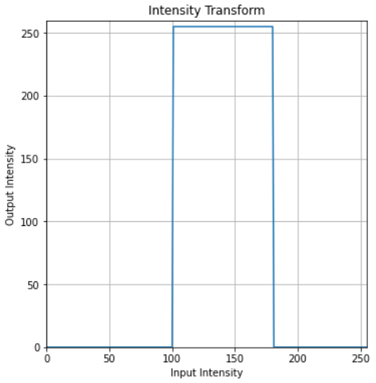

Figure 5(b) - Intensity transformation for gray matter

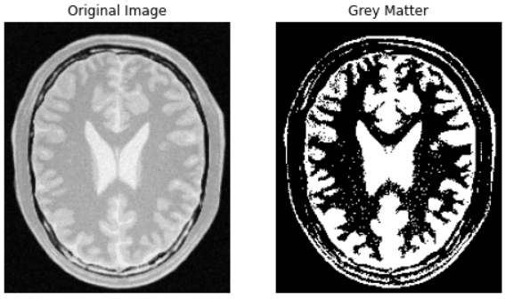

Figure 6(b) - Accentuated gray matter

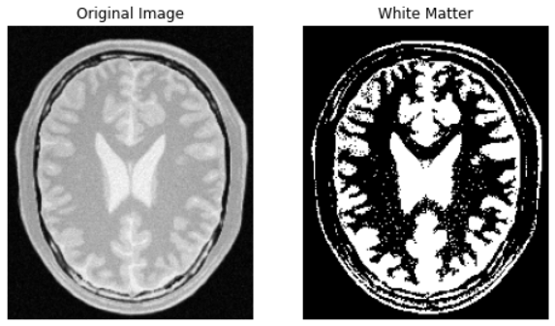

Figure 7(a) - Accentuated white matter

Question 03

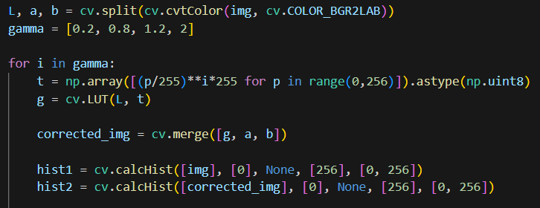

Figure 8 - Gamma correction and generating histograms

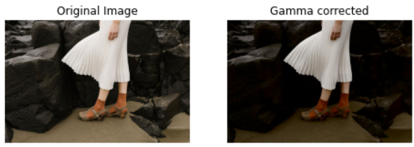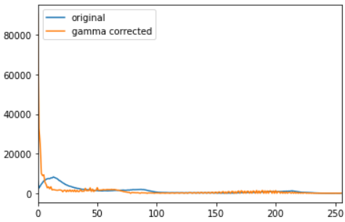

Figure 9(d) - Gamma = 2

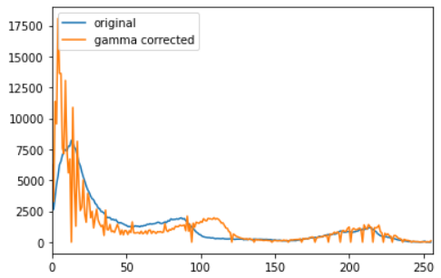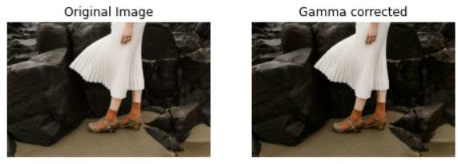

Figure 10(c) - Gamma = 1.2

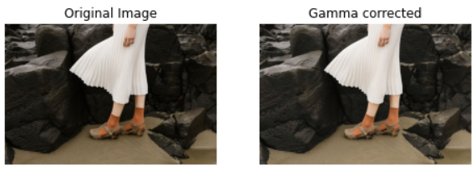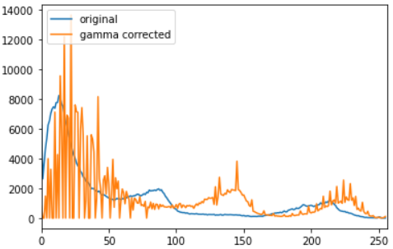

Figure 9(b) - Gamma = 0.8

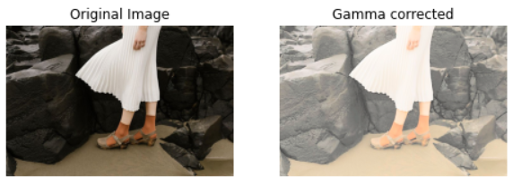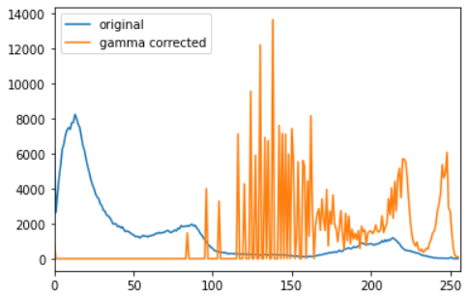

Figure 9(a) - Gamma = 0.2

Question 04

1. image_hsv = cv.cvtColor(image_bgr, cv.COLOR_BGR2HSV)

h, saturation_plane, v = cv.split(image_hsv)

1. def intensity_transform(x, a, sigma=70):

f_x = np.clip(x+a*128*np.exp(-(x-128)**2/(2*sigma**2)), 0, 255)

return f_x

# Apply the intensity transform function

transforemed_saturation_plane = intensity_transform(saturation_plane, 0.4)

* Visually Pleasing results were obtained for values in the [0.3, 0.4] range.

(d) image_copy = image_hsv.copy()

image_copy[:, :, 1] = transforemed_saturation_plane

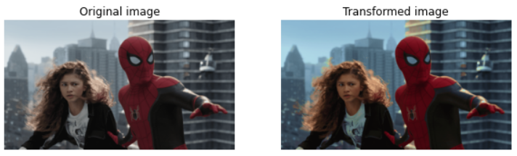

Figure 11 - Original and Enhanced images

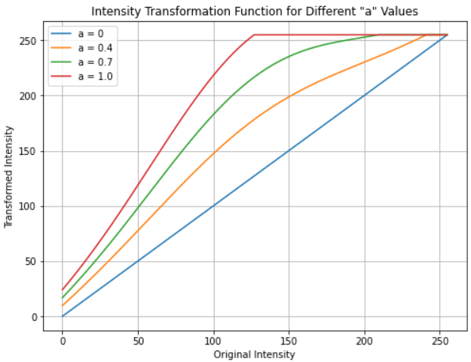

Figure 12 - Intensity Transformations

intensity_values = np.arange(256)

a_values = [0, 0.4, 0.7, 1.0]

for a in a_values:

transformation_values = intensity_transform(intensity_values, a)

Question 05

def histogram_equalization(im):

cv.imread(im,cv.IMREAD_GRAYSCALE)

    histogram = np.zeros(256, dtype=int)

    for pixel_value in img.flat:

        histogram[pixel_value] += 1

    cdf = np.zeros(256, dtype=int)

    cdf[0] = histogram[0]

    for i in range(1, 256):

        cdf[i] = cdf[i - 1] + histogram[i]

    num_pixels = img.size

    equalized_image = np.zeros_like(img)

    for i in range(img.shape[0]):

        for j in range(img.shape[1]):

            pixel_value = img[i, j]

            equalized_pixel = int((cdf[pixel_value] / num_pixels) * 255)

            equalized_image[i, j] = equalized_pixel

    histogram_equalized = np.zeros(256, dtype=int)

    for pixel_value in equalized_image.flat:

        histogram_equalized[pixel_value] += 1

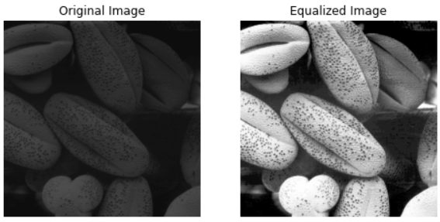

Figure 13 - Images before and after equalization

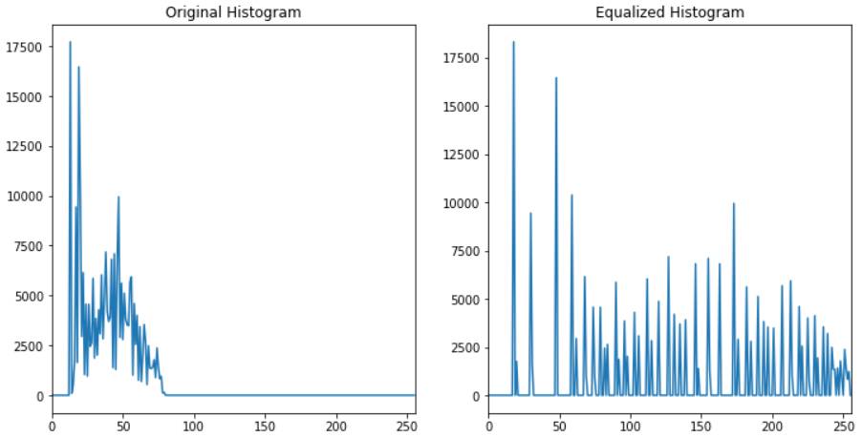

Figure 14 - Histogram before and after equalization

Question 06

1. hsv_image = cv.cvtColor(image, cv.COLOR_BGR2HSV)

hue, saturation, value = cv.split(hsv_image)

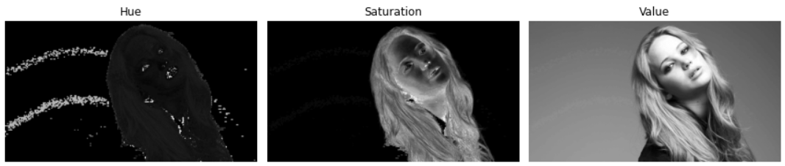

Figure 15

1. The foreground object is highly saturated compared to the background. Therefore, the Saturation plane is the appropriate plane for the threshold in extracting the foreground mask.
2. saturation_min = 15, saturation_max = 255

foreground_mask = cv.inRange(saturation, saturation_min, saturation_max)

foreground_mask = cv.morphologyEx(foreground_mask, cv.MORPH_CLOSE, cv.getStructuringElement(cv.MORPH_ELLIPSE,(80, 80)))

foreground = cv.bitwise_and(image, image, mask=foreground_mask)

histogram = cv.calcHist([foreground], [0], foreground_mask, [256], [0, 256])

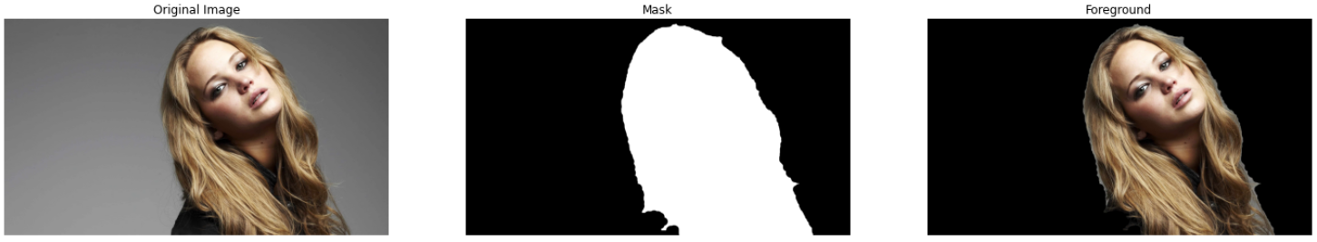

Figure 16

1. cumulative_histogram = np.cumsum(histogram)
2. hsv_foreground = cv.cvtColor(foreground, cv.COLOR_BGR2HSV)

value_foreground = hsv_foreground[:, :, 2]

equalized_value_foreground = cv.equalizeHist(value_foreground)

hsv_foreground[:,:,2] = equalized_value_foreground

1. background_mask = cv.bitwise_not(foreground_mask)

extracted_background = cv.bitwise_and(image, image, mask=background_mask)

result = cv.add(extracted_background, cv.cvtColor(hsv_foreground, cv.COLOR_HSV2BGR))

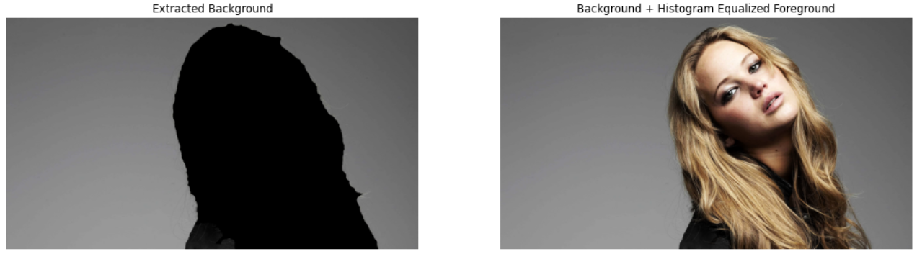

Figure 17

Question 07

1. sobel_v = np.array([(-1, -2, -1), (0, 0, 0), (1, 2, 1)], dtype='float32')

sobel_h = np.array([(-1, 0, 1), (-2, 0, 2), (-1, 0, 1)], dtype='float32')

imv = cv.filter2D(im, -1, sobel_v)

imh = cv.filter2D(im, -1, sobel_h)

grad_mag = np.sqrt(imv**2 + imh**2)

1. rows, columns = im.shape

kernal_size = 3

imv = np.zeros((rows-kernal_size+1, columns-kernal_size+1), dtype='float32')

imh = np.zeros((rows-kernal_size+1, columns-kernal_size+1), dtype='float32')

for row in range(rows-kernal_size+1):

for column in range(columns-kernal_size+1):

imv[row, column] = np.sum(im[row:row+kernal_size, column:column+kernal_size] * sobel_v)

imh[row, column] = np.sum(im[row:row+kernal_size, column:column+kernal_size] * sobel_h)

grad_mag = np.sqrt(imv**2 + imh**2)

1. sobel_h_kernel = np.array([1, 2, 1], dtype=np.float32)

sobel_v_kernel = np.array([1, 0, -1], dtype=np.float32)

im1 = cv.sepFilter2D(im, -1, sobel_h_kernel, sobel_v_kernel)

im2 = cv.sepFilter2D(im, -1, sobel_v_kernel, sobel_h_kernel)

grad_mag = np.sqrt(imv**2 + imh**2)

In all the methods, similar results were obtained.

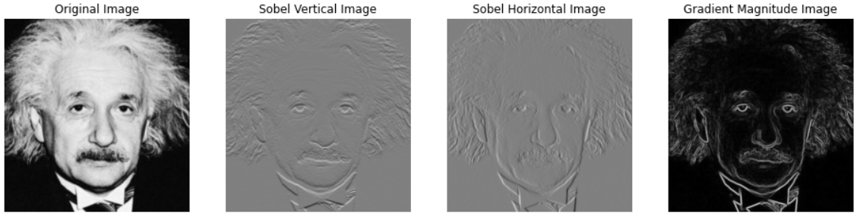

Figure 18

Question 08